eTransfer Payment Instructions for School Fees (for Families)
Edmonton Public Schools now accept Interac email transfer (eTransfer) at some schools. eTransfer payments for school fees is a two-step process and requires that you log into SchoolZone as well as your bank application:

STEP ONE
- Log into SchoolZone for each student at the school. You may only pay for one student at a time.
- Select the fees to pay by placing a check mark in the box next to the fee and then select the “Proceed to Pay” button.
- On the “Payment Options” screen, select ‘eTransfer’ to be taken to the “Payment Details” page.
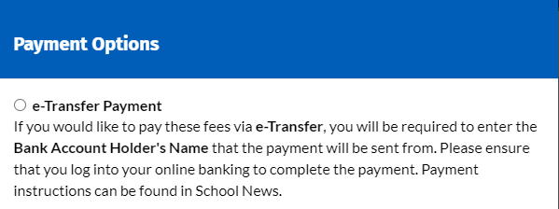
- Record the name of the bank account holder (i.e., your name) in the ‘Bank Account Holder Name’ field and verify that the amount and fees being paid are correct. Press the “Add Payment Details” button.
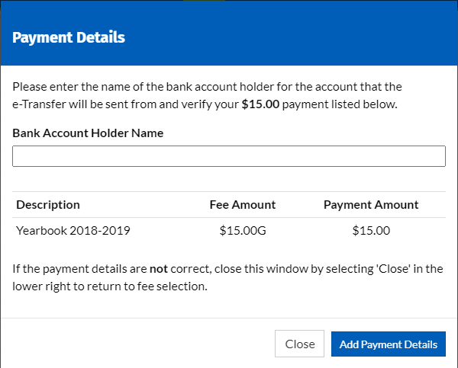

STEP TWO
- Log into your personal online banking application. Note: your bank may charge a nominal fee for each Interac eTransfer.
- Use the Email address indicated in SchoolZone News for your school.
  - Ensure that you are using this email address and that your bank acknowledges that “The Edmonton School Division or Edmonton School District No. 7 uses Autodeposit. That means the money you are sending is automatically deposited into their account without needing to answer a security question. Make sure the name and recipient’s contact information are correct.”
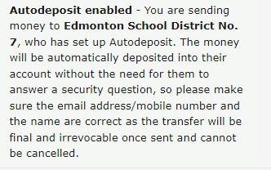
  - If the above message or similar message does not appear, verify that you have typed in the correct email address. DO NOT SEND THE MONEY IF THIS MESSAGE DOES NOT APPEAR. Contact the school to confirm the correct email address if this message does not appear.
  - Please note that each school has a unique email address and not all schools accept eTransfer at this time. Pay each student’s fees separately from other student’s and to the correct school email.
- Complete the eTransfer for the amount that was verified in SchoolZone. Please enter the name of the student whose fees are being paid in the notes/message of the eTransfer.

